SORTING

We have spent a significant amount of time in class understanding sorting. There are a number of reasons which tell us why sorting is important. Here are a few important ones.

Procedures for sorting are parts of many large software systems. Design of efficient sorting algorithms is necessary to achieve overall efficiency of these systems. Computers spend more time sorting than anything else, historically 25% on mainframes.

Sorting is well studied problem from the analysis point of view. Sorting is one of the few problems where provable lower bounds exist on how fast we can sort. In sorting, we are given an array A[1..n] of n numbers We are to reorder these elements into increasing (or decreasing) order.

More generally, A is an array of objects and we sort them based on one of the attributes - the key value. The key value need not be a number. It can be any object from a totally ordered domain. Totally ordered domain means that for any two elements of the domain, x and y, either x < y, x = y or x > y.

Slow Sorting Algorithms

There are a number of well-known slow O(n²) sorting algorithms. These include the following:

Bubble sort: Scan the array. Whenever two consecutive items are found that are out of order, swap them. Repeat until all consecutive items are in order.

Insertion sort: Assume that A[1..i - 1] have already been sorted. Insert A[i] into its proper position in this sub array. Create this position by shifting all larger elements to the right.
Selection sort: Assume that A[1..i - 1] contain the i - 1 smallest elements in sorted order. Find the smallest element in A[i..n] Swap it with A[i].

These algorithms are easy to implement. But they run in O(n²) time in the worst case. We will take a look at these algorithms below

Selection sort
One form of Ascending order Selection sort works by finding ("selecting") the smallest value in the set and placing it at the beginning of the set, then finding the second smallest value and placing it just after the smallest, then finding the third smallest value and placing it just after the second smallest, etc.
In the following algorithm, let i represent the rank of the value we wish to select. (i=1 means we are selecting the smallest value, i=2 means we are selecting the 2nd smallest value, etc.)
- Set i to 1.
- Find the ith smallest value in the set by scanning entries of the array beginning at index i-1. Let s be the index of the ith smallest element.
- Swap the values at indices i-1 and s.
- Increment i. If i is less than n, go to Step 2. (We do not have to select the nth smallest value, because that is the largest value in the set, and will naturally end up in the last entry of the array once all of the smaller values have been selected.)
The first pass of selection sort requires n-1 comparisons to find the 1st smallest element. The second pass requires n-2 comparisons to find the 2nd smallest, and so on. The running time of selection sort is therefore
(n-1) + (n-2) + (n-3) + ... + 1 = n*(n-1)/2 = O(n²)
In Java, an array of integers may be selection sorted as follows:
void function(int[] array)
{
for (int i = 1 ; i < array.length ; i++) {

// find the index of the ith smallest value
int s = i-1;
for (int j = i ; j < array.length ; j++) {
if (array[j] < array[s]) {
s = j;
}
}

// swap the ith smallest value into entry i-1
int temp = array[i-1];
array[i-1] = array[s];
array[s] = temp;

}
}

Exercise

Run the above given algorithm on the following array. Show the contents of array after performing each iteration of loop.

5
9
2
19
7
1
4
13
6
2
15
3
i =
i =
i =
i =
i =
i =
i =
i =
i =
i =
i =

Exercise

- Write an algorithm to calculate the maximum number out of an array of integers. Estimate its running time.

- Write an algorithm to calculate the maximum number and minimum number out of an array of integers simultaneously. Estimate its running time.

- The algorithm of selection sort, described in the beginning works by finding the smallest number and putting it into its correct position. You can use the algorithm in exercise 2 (find min & max) to improve performance of selection sort by placing smallest number in the beginning and the largest at the end in one iteration. Write the complete selection sort algorithm.

Insertion sort
Insertion sort works by dividing the array into a sorted section (the left side of the array) and an unsorted section (the right side), and then repeatedly taking a value out of the unsorted section and inserting it into the sorted section in the appropriate place.
In the following algorithm, let i represent the size of the sorted left side of the array.
- Set i to 1. (The first element of the array, by itself, constitutes the sorted section.)
- Move the value at index i (the first element of the unsorted right side of the array) leftwards until it is in its correct place in the sorted section.
- Increment i. If i is less than n, go to Step 2. (We terminate when i = n, meaning the sorted section encompasses the entire array.)
In the best case, the input array is already sorted. Insertion sort will perform one comparison to insert each element into the sorted section (these comparisons will reveal that each value is already in the correct place, and does not need to be moved). The best case running time is therefore O(n).
In the worst case, the input array is in reverse order. Insertion sort will perform one comparison and swap on the second element to move it into the first position, two comparisons and swaps on the third element to move it into the first position, three comparisons and swaps on the fourth element to move it into the first position, and so on. The worst case running time is therefore
1 + 2 + 3 + ... + n-1 = n*(n-1)/2 = O(n²)

Java Based Implementation
In Java, an array of integers may be insertion sorted as follows:
void insertionSort(int[] array)
{
for (int i = 1 ; i < array.length ; i++) {

// start with the leftmost element of the unsorted section
int j = i;

// move the value leftwards until it should not move further
// or it reaches the beginning of the array
while (j > 0 && array[j] < array[j-1]) {

// swap value one place to the left
int temp = array[j];
array[j] = array[j-1];
array[j-1] = temp;
j--;
}
}
}

Run the above given algorithm on the following array. Show the contents of array after performing each iteration of loop.

5
9
2
19
7
1
4
13
6
2
15
3
i =
i =
i =
i =
i =
i =
i =
i =
i =
i =
i =

Bubble Sort

Bubble sort, sometimes shortened to bubblesort, also known as exchange sort, is a simple sorting algorithm. It works by repeatedly stepping through the list to be sorted, comparing two items at a time and swapping them if they are in the wrong order. The pass through the list is repeated until no swaps are needed, which means the list is sorted. The algorithm gets its name from the way smaller elements "bubble" to the top (i.e. the beginning) of the list via the swaps. Because it only uses comparisons to operate on elements, it is a comparison sort.
A simple way to express bubble sort in pseudo code is as follows:

function bubble_sort(list L, number listsize)
loop
has_swapped := 0 //reset flag
for number i from 1 to (listsize - 1)
if L[i] > L[i + 1] //if they are in the wrong order
swap(L[i], L[i + 1]) //exchange them
has_swapped ← 1 //we have swapped at least once, list may not be sorted yet
endif
endfor
//if no swaps were made during this pass, the list has been sorted
if has_swapped = 0
exit
endif
endloop
endfunction

Analysis

Worst-case performance
Bubble sort has worst-case complexity O(n²). on lists of size n. To see why, note that each element is moved no more than one step each time. No element can be more than a distance of n - 1 away from its final sorted position, so we use at most n - 1 = O(n) operations to move an element to its final sorted position, and use no more than (n - 1)² = O(n²) operations in the worst case.

Best-case performance
When a list is already sorted, bubblesort will pass through the list once, and find that it does not need to swap any elements. This means the list is already sorted. Thus bubblesort will take O(n) time when the list is completely sorted. It will also use considerably less time if the elements in the list are not too far from their sorted places.
Divide and Conquer Strategy

The ancient Roman politicians understood an important principle of good algorithm design (although they were probably not thinking about algorithms at the time). You divide your enemies (by getting them to distrust each other) and then conquer them piece by piece. This is called divide-and-conquer. In algorithm design, the idea is to take a problem on a large input, break the input into smaller pieces, solve the problem on each of the small pieces, and then combine the piecewise solutions into a global solution.
But once you have broken the problem into pieces, how do you solve these pieces? The answer is to apply divide-and-conquer to them, thus further breaking them down. The process ends when you are left with such tiny pieces remaining (e.g. one or two items) that it is trivial to solve them. Summarizing, the main elements to a divide-and-conquer solution are

Divide: the problem into a small number of pieces

Conquer: solve each piece by applying divide and conquer to it recursively

Combine: the pieces together into a global solution.

Merge Sort

Divide and conquer strategy is applicable in a huge number of computational problems. The first example of divide and conquer algorithm we will discuss is a simple and efficient sorting procedure called

We are given a sequence of n numbers A, which we will assume are stored in an array A[1..n]. The objective is to output a permutation of this sequence sorted in increasing order. This is normally done by permuting the elements within the array A. Here is how the merge sort algorithm works:

• (Divide :) split A down the middle into two subsequences, each of size roughly n/2
• (Conquer :) sort each subsequence by calling merge sort recursively on each.
• (Combine :) merges the two sorted subsequences into a single sorted list.

Let’s design the algorithm top-down. We’ll assume that the procedure that merges two sorted list is available to us. We’ll implement it later. Because the algorithm is called recursively on sub lists, in addition to passing in the array itself, we will pass in two indices, which indicate the first and last indices of the sub-array that we are to sort.

The call MergeSort(A, p, r) will sort the sub-array A[p : r] and return the sorted result in the same sub-array.

Here is the overview. If r = p, then this means that there is only one element to sort, and we may return immediately. Otherwise if (p ≠ r) there are at least two elements, and we will invoke the divide-and-conquer. We find the index q, midway between p and r, namely q = (p + r)/2 (rounded down to the nearest integer).

Then we split the array into sub-arrays A[p : q] and A[q + 1 : r].

Call MergeSort recursively to sort each sub-array. Finally, we invoke a procedure (which we have yet to write) which merges these two sub-arrays into a single sorted array.
Here is the MergeSort algorithm.

MERGE-SORT( array A, int p, int r)
1 if (p < r)
2 then
3 q (p + r)/2
4 MERGE-SORT(A, p, q) // sort A[p..q]
5 MERGE-SORT(A, q + 1, r) // sort A[q + 1..r]
6 MERGE(A, p, q, r) // merge the two pieces

The following figure illustrates the dividing (splitting) procedure.
7 5 2 4 1 6 3 0
1 6 3 0 7 5 2 4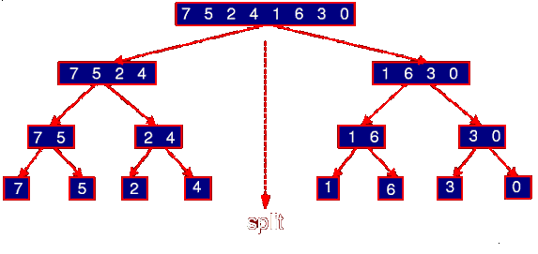
4 1 6 3 07 5 2 4 1 6 3 0 Figure 3.1: Merge sort divide phase

Merging:

All that is left is to describe the procedure that merges two sorted lists. Merge(A, p, q, r) assumes that the left sub-array, A[p : q], and the right sub-array, A[q + 1 : r], have already been sorted.

We merge these two sub-arrays by copying the elements to a temporary working array called B. For convenience, we will assume that the array B has the same index range A, that is, B[p : r]. (One nice thing about pseudo-code, is that we can make these assumptions, and leave them up to the programmer to figure out how to implement it.)

We have to indices i and j, that point to the current elements of each sub-array. We move the smaller element into the next position of B (indicated by index k) and then increment the corresponding index (either i or j). When we run out of elements in one array, then we just copy the rest of the other array into B. Finally, we copy the entire contents of B back into A. (The use of the temporary array is a bit unpleasant, but this is impossible to overcome entirely. It is one of the shortcomings of MergeSort, compared to some of the other efficient sorting algorithms.)

Here is the merge algorithm:

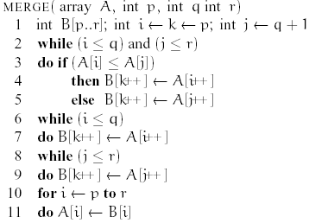0 1 2 3 4 5 6 7
0 1 3 6 2 4 5 75 7 2 4 1 6 0 35 2 4 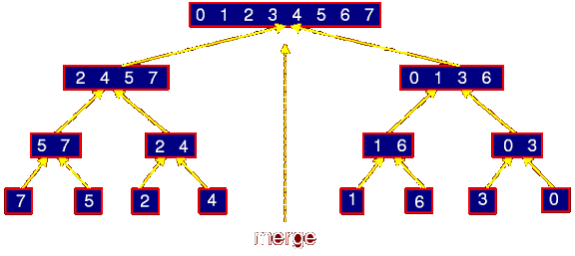1 6 3 0merg eFigure Merge sort: combine phase

Analysis of Merge Sort

First let us consider the running time of the procedure Merge(A, p, q, r).

Let n = r - p + 1 denote the total length of both the left and right sub-arrays. What is the running time of Merge as a function of n? The algorithm contains four loops (none nested in the other). It is easy to see that each loop can be executed at most n times. (If you are a bit more careful you can actually see that all the while-loops together can only be executed n times in total, because each execution copies one new element to the array B, and B only has space for n elements.) Thus the running time to Merge n items is Θ(n).

Let us write this without the asymptotic notation, simply as n. (We’ll see later why we do this.)

Now, how do we describe the running time of the entire MergeSort algorithm? We will do this through the use of a recurrence, that is, a function that is defined recursively in terms of itself. To avoid circularity, the recurrence for a given value of n is defined in terms of values that are strictly smaller than n. Finally, a recurrence has some basis values (e.g. for n = 1), which are defined explicitly.

Let T(n) denote the worst case running time of MergeSort on an array of length n.

If we call MergeSort with an array containing a single item (n = 1) then the running time is constant. We can just write T(n) = 1, ignoring all constants.

For n > 1, MergeSort splits into two halves, sorts the two and then merges them together. The left half is of size |n/2| and the right half is ⎣n/2⎦.

How long does it take to sort elements in sub array of size ⎡n/2⎤? We do not know this but because ⎣n/2⎦ < n for n > 1, we can express this as T(⎡n/2⎤). Similarly the time taken to sort right sub array is expressed as T(⎣n/2⎦). In conclusion we have
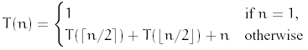

This is called recurrence relation, i.e., a recursively defined function. Divide-and-conquer is an important design technique, and it naturally gives rise to recursive algorithms. It is thus important to develop mathematical techniques for solving recurrences, either exactly or asymptotically.

Let’s expand the terms.

T(1) = 1
T(2) = T(1) + T(1) + 2 = 1 + 1 + 2 = 4
T(3) = T(2) + T(1) + 3 = 4 + 1 + 3 = 8
T(4) = T(2) + T(2) + 4 = 8 + 8 + 4 = 12
T(5) = T(3) + T(2) + 5 = 8 + 4 + 5 = 17
. . .
T(8) = T(4) + T(4) + 8 = 12 + 12 + 8 = 32
. . .
T(16) = T(8) + T(8) + 16 = 32 + 32 + 16 = 80
. . .
T(32) = T(16) + T(16) + 32 = 80 + 80 + 32 = 192

What is the pattern here? Let’s consider the ratios T(n)/n for powers of 2:

T(1)/1 = 1 T(8)/8 = 4
T(2)/2 = 2 T(16)/16 = 5
T(4)/4 = 3 T(32)/32 = 6

This suggests T(n)/n = log n + 1 Or, T(n) = n log n + n which is Θ(n log n) (using the limit rule).

Exercise

- Write java implementation for the merge sort algorithm given above.
- The algorithm above divides the array into two halves and does sorting. Develop an algorithm that divides the array into three halves and does sorting.
- Calculate the running time of the algorithm, you developed in step 1

Quick Sort

Fundamentally, QuickSort is based on a simple idea: Pick some key. Put all the records that have a smaller key than the selected key at the beginning of the array, and put all the records with larger keys at the end. Then apply the same procedure recursively to each group of records, continuing until you get down to groups of size zero or one. However, organizing all this and doing it efficiently requires some cleverness.

A basic operation in QuickSort is the algorithm that we call Partition (called quicksort step below), which applies the procedure described in the preceding paragraph to the records between two specified positions in the array. The first record in the sequence is used as a \pivot." Records with smaller keys than the pivot are moved to the beginning of the sequence; records with larger keys are moved to the end. The pivot element itself ends up between the two groups of records. Note that records within one of the groups are not yet sorted, but the pivot element is in the final position that it will occupy when the entire sequence has been sorted. For an array of integers, QuickSortStep can be coded as follows:

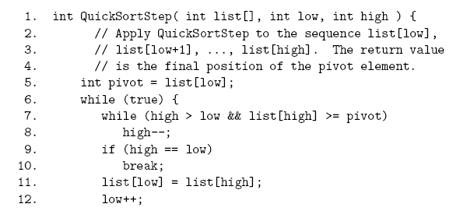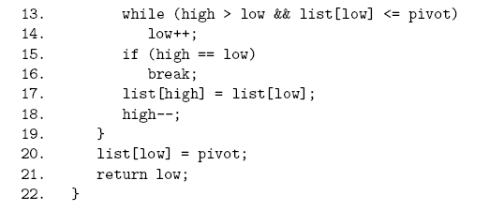
In this algorithm, pivot holds the pivot value. As the values of low and high change, positions below low hold items that are known to be less than or equal to the pivot, and positions above high hold items that are known to be greater than or equal to the pivot.

Positions between low and high hold items that are unclassified. Low and high gradually move towards each other. When they become equal, there are no more unclassified items and the mutual value of low and high represents the final position of the pivot, between the two groups of items. This final position is returned by the function, since it is needed in the full QuickSort algorithm.

You should think of line 5 as leaving an empty space in the array at position low. Lines 7 and 8 look for an item from the top end of the sequence that is less than the pivot and therefore can be moved to position low. When this item is moved, in line 11, there is an empty space in position high. Lines 13 and 14 look for an item greater than the pivot to fill this space. When this item is moved in line 17, the empty space is once again in position low. We break out of the loop as soon as high becomes equal to low. In line 20, the pivot is placed into the final position of the empty space.

With a QuickSortStep function in hand, it is easy to write a QuickSort function. The function is recursive and is written so as to apply to a specified range of positions in the array. If A is an array of n integers, we would sort the entire array by calling QuickSort(A,0,n - 1).

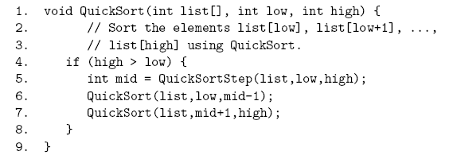

The base case of the recursion occurs when high <= low. In this base case, the array segment that is being sorted has fewer than two elements, so there is nothing to do. In the recursive case, we start by applying QuickSortStep to the array segment. The variable mid is the position of the pivot element that was used by QuickSortStep.

This element is in its correct final location. We can then complete the sort by sorting the elements in locations low through mid - 1, which precede the pivot, and the elements in positions mid + 1 through high, which follow the pivot. Note that either of these sub-segments might have length zero or one. In that case, the corresponding call to QuickSort will return without doing anything.
QuickSort is quite fast on average. Its average case run time is O(n log(n)), although this fact is not so easy to prove. We can note that the run time for QuickSortStep is proportional to the length of the array segment to which it is applied. When QuickSort is applied to an array of n elements, the call to QuickSortStep on the top level does work proportional to n.

On the next level, QuickSortStep is applied to two sub-arrays, but the combined length of these sub-arrays is just n _ 1, so the total work done by the two calls to QuickSortStep on the second level of the recursion is still bounded by a constant times n. Three levels down the recursion, QuickSortStep can be applied to as many as four sub-arrays, but the combined length of all the sub-arrays is less than n and so the total work done by all calls to QuickSortStep on the third level of the recursion is also bounded by a constant times n. In fact, the work done on every level of the recursion is bounded by a constant times n. If the recursion continues k levels deep, the total work done is bounded by a constant times n - k. Now, if QuickSortStep always divided the sub-array into two equal parts, there would be log(n) levels, and the run time would be bounded by a constant times n*log(n). Thus, the run time would be O(n log(n)). QuickSortStep does not usually divide the sub-array exactly in half. But it comes close enough on average that the average run time is still O(n log(n)).

In practice, QuickSort is significantly faster than HeapSort on average (by a constant multiple). However, the worst-case run time for QuickSort is _(n2). This worst case occurs, curiously, when QuickSort is applied to an array that is already in sorted order. In this case, the pivot element chosen by QuickSortStep is already in its final position, so that QuickSortStep will divide a subarray of length m into an array of length 0 and an array of length m - 1.

For an array of length n, QuickSortStep is applied to n elements on the top level of the recursion. On the second level, it is applied to one sub-array with n-1 elements. On the third level, it is applied to n-2 elements and so on. There are n levels to this recursion, rather than log(n), and the total amount of work done is proportional to nexp2. For randomly ordered arrays, run times close to the worst case are very rare.

However, if QuickSort is applied to arrays that are sorted or almost sorted, the run time can be a problem. This problem is sometimes addressed by using Randomized QuickSortStep. In this version, instead of choosing the first element of the sub-array as the pivot, the pivot element is chosen randomly from the sub-array. This random element is swapped with the first element, and then Randomized QuickSortStep proceeds in the same way as the regular version.

This does not change the worst-case run time of QuickSort, but it does mean that the worst case is extremely unlikely to occur for almost-sorted arrays. Since almost-sorted arrays are common in some application, Randomized QuickSort is often preferred over regular QuickSort as a general purpose sorting algorithm.

